Electric Protection

Abstract
This document details the selection and design of electric protection of the inverter, which incorporates the following parts:
- Background Knowledge
  - Circuit-breaker
  - Residual Current Devices
  - Protection functions
  - Breaker types
  - RCD Technology
  - Supply Voltage Response
  - Types of Residual Current Devices
  - Operating Times
- Design Requirements
- Possible Devices

1. Background Knowledge

1.1 Circuit-breaker ^{[1]}
A mechanical switching device, capable of making, carrying and breaking currents under normal circuit conditions and also making, carrying for a specified time and breaking currents under specified abnormal circuit conditions such as those of short-circuit.

1.2 Residual Current Devices ^{[1]}
A residual current device disconnects a circuit whenever it detects that the electric current is not balanced between the energized conductor and the return neutral conductor.
The residual current releases are associated with the circuit-breaker in order to obtain two main functions in a single device:
- Protection against overloads and short-circuits;
- Protection against indirect contacts (presence of voltage on exposed conductive parts due to loss of insulation)

1.3 Protection functions
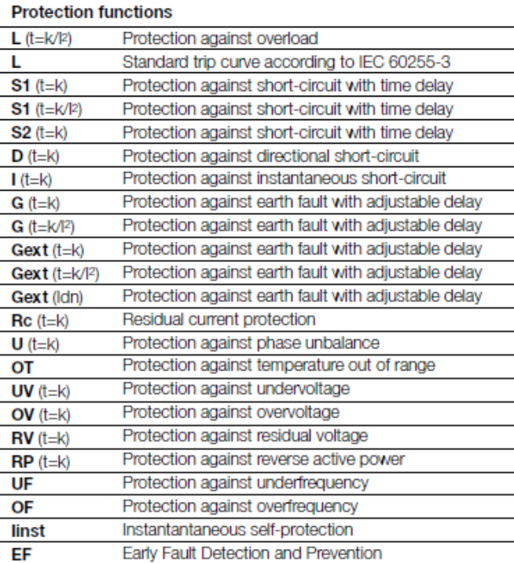

1.4 Breaker types
MCB (Miniature Circuit Breaker) — its rated current not more than 100 A. Trip characteristics normally not adjustable
MCCB (Molded Case Circuit Breaker) — its rated current up to 2500 A. Thermal or thermal-magnetic operation. Trip current may be adjustable in larger ratings.
Residual-current Circuit Breaker (RCCB) — detects current imbalance, but does not provide over-current protection.
Residual current breaker with over-current protection (RCBO) — combines the functions of an RCD and an MCB in one package.

1.5 RCD Technology ^{[2]}
- Voltage Independent RCD (VI)
VIs relies on the energy of the residual current to activate them.

- Voltage Dependent RCD (VD)
VDs use main supply voltage for tripping mechanism

1.6 Supply Voltage Response
Some VD RCDs, in addition to providing shock protection, are designed to open automatically if the supply voltage falls below a certain level. This is referred to as under voltage release. Some of those devices will automatically reclose on restoration of the supply.

1.7 Types of Residual Current
- Type AC RCDs which can detect full wave AC residual currents only.
- Type A RCDs which can detect full wave AC and pulsating DC residual currents.
- Type B RCDs which can detect full wave AC, pulsating DC and pure DC residual currents.

1.8 Operating Times

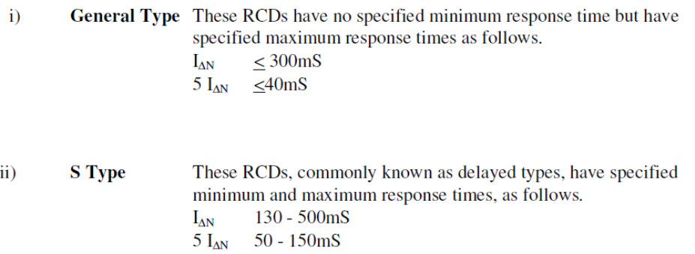

S types are usually cascaded with general type. The purpose is ensure that a residual current on a sub-circuit causes only its RCD to trip and does not cause the upstream RCD to trip unless the fault is sustained beyond a certain time. This is referred to as Discrimination. S type should be used upstream and general type downstream.

2. Design Requirements

2.1 Circuit Breaker requirement
Rated Current (all working temperatures) | 10 A
Voltage Rating [peak working voltage] | 311 V
Frequency | 50 Hz
Maximum Interrupting Capacity [current] Icu | 20 A
Overload ratings | I =16A t=3s
Type | A, B
Short circuit Protection | Yes
Residual current protection | Yes
UV protection | Yes
OV protection | Yes

- The breaker type should be RCBO
- One circuit breaker with residual protection is required

2.2 Contactors requirement
Two three-phase contactors are required for the design in case that one fails.
Rated Current (all working temperatures) | 50 A
Voltage Rating [peak working voltage] | 311 V
Frequency | 50 Hz

3. Possible Devices

3.1 FND Electronics - FDC1-P50 AC Contactors
Rated Current (all working temperatures) | 50 A
Voltage Rating [peak working voltage] | 311 V
Frequency | 50 Hz
Price (USD) | 2-10

3.2 FND Electronics – DR7NL-1030 (AC) RCBO (Residual current breaker with overload)
Rated Current (all working temperatures) | 10 A
Voltage Rating [peak working voltage] | 311 V
Frequency | 50 Hz
Maximum Interrupting Capacity [current] Icu | 20 A
Price (USD)^{[3]} | 9.14
Type | A, B
Short circuit Protection | Yes
Residual current protection | Yes
UV protection | Yes
OV protection | Yes
As suggested by the salesperson in FND, the lacks of short circuit and residual protection are well-compensated by using the RCBO. This model is an AC type RCBO, which can detect full wave AC residual currents only. The A-type RCBO is priced at 10.06 USD, which can detect full wave AC and pulsating DC residual currents.

3.3 CB7LE-63 (Electronic Type) RCBO RCCB with over Current Protection
Rated Current (all working temperatures) In | 40 A
Voltage Rating [rms voltage] | 230 V
Frequency | 50 Hz
Maximum Interrupting Capacity [current] Icu | See below
Price (USD)^{[3]} | 5 - 10
Type | A, B
Short circuit Protection | Yes
Residual current protection | Yes
UV protection | Yes
OV protection | Yes
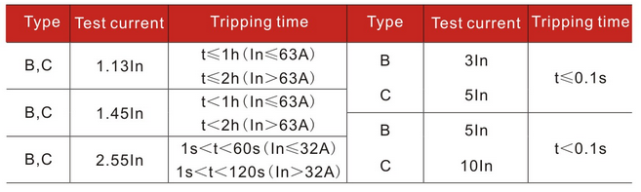

3.4. Tengen CJ19 Contactor
Rated Current (all working temperatures) | 100 A
Voltage Rating [peak working voltage] | 380 V
Frequency | 50 Hz
Price (USD) | 5-8
It provides surge protection for control signals

3.5. Tengen ID Residual current circuit breaker (RCCB)
Rated Current (all working temperatures) In | 40 A
Voltage Rating [rms voltage] | 400 V
Frequency | 50 Hz
Price (USD)^{[3]} | 5 - 10
Rated Residual Operating Current (mA) | 100, 300
Type | A, B
Short circuit Protection | Yes
Residual current protection | Yes
UV protection | Yes
OV protection | No
Tengen ID RCCB also provides earth fault detection

3.6 ABB RCBO DS 261 / DS 271
Rated Current (all working temperatures) In | 32 A
Voltage Rating [rms voltage] | 230 V
Frequency | 50/60Hz
Price (USD)^{[3]} | 111.85
Rated Residual Operating Current (mA) | 10, 30
Type | A, B
Short circuit Protection | Yes
Residual current protection | Yes
UV protection | Yes
OV protection | Yes

The residual current is substantially lower than the others but the cost is much higher.

Reference
[1] ABB, Electrical installation handbook - Protection, control and electrical devices, 2010
[2] Electro-Technical Council of Ireland Limited, Guide to the Selection & Use of Residual Current Devices, 2005

